Print @ Home
Design Requirements Document (DRD)

Contents
1 Revision History 5
2 Purpose of This Document 5
3 Glossary 6
3.1 Asset 6
3.2 Template 6
3.3 Project 6
3.4 Collections 6
3.5 Product Definition 6
4 Content Specifications 7
4.1 Assets/Associations for PDB 7
4.1.1 Font 8
4.2 Sorting Collections & Art/Text Assets within Application 8
4.2.1 Sorting From the Primary Collection Navigation Screen 8
4.2.2 Left Rail Sort within Creative Studio 9
4.3 Blank Templates 9
5 Global (Main) Tool Bar 10
5.1 File 10
5.1.1 Return to welcome screen 10
5.1.2 Start a New Project 10
5.1.3 Start a New Project from Scratch 10
5.1.4 Open My Saved Project 10
5.1.5 Close 11
5.1.6 Save 11
5.1.7 Save As 11
5.1.8 Export / Import 11
5.1.9 Print Preview 11
5.1.10 Print 12
5.1.11 Other Finishing Options 12
5.1.12 Options 12
5.1.13 Recent Projects 13
5.2 Edit 13
5.2.1 Undo 13
5.2.2 Redo 13
5.2.3 Cut 13
5.2.4 Copy 14
5.2.5 Paste 14
5.2.6 Delete 14
5.2.7 Select All 14
5.2.8 Layers 14
5.3 View 15
5.3.1 View All 15
5.3.2 Page Width 15
5.3.3 Selection 15
5.3.4 Zoom 15
5.3.5 Ruler 15
5.3.6 Grid 15
5.3.7 Tool Tips 16
5.3.8 Scratch Pad – Phase 2 16
5.3.9 Snap to Grid 16
5.4 Insert 16
5.4.1 Text 16
5.4.2 Text on a Curve 16
5.4.3 Image/Photo 16
5.4.4 Border 17
5.4.5 Background 17
5.4.6 Monogram – Phase 2 17
5.4.7 Calendar 17
5.5 Text 18
5.5.1 Add Text 18
5.5.2 Add Text on a Curve 18
5.5.3 Recolor Text 18
5.5.4 Format Font 18
5.5.5 Adjust line spacing 19
5.5.6 Adjust letter spacing 19
5.5.7 Horizontal Text Alignment 19
5.5.8 Vertical Text Alignment 19
5.5.9 Text Box Position 20
5.5.10 Flip Text Box – Phase 2 21
5.5.11 Rotate Text Box 21
5.5.12 Text Box Size 21
5.6 Image 22
5.6.1 Add Image/Photo 22
5.6.2 Recolor Image 23
5.6.3 Recolor Photo 23
5.6.4 Format Image/Photo 23
5.6.5 Crop 23
5.6.6 Fade Edges 23
5.6.7 Special Effects 23
5.6.8 Photo Correcting 23
5.6.9 Image Position 23
5.6.10 Flip Image 25
5.6.11 Rotate Image 25
5.6.12 Image Size 25
5.7 Tools 26
5.7.1 Spell Check 26
5.7.2 Text Editor 26
5.7.3 Image Editor 26
5.7.4 Custom Patterns – Phase 2 26
5.7.5 Monogram Wizard – Phase 2 26
5.7.6 Template Wizard 26
5.7.7 Address Book 27
5.8 Help 27
5.8.1 [PAH] Help 27
5.8.2 Check for Updates 27
5.8.3 Go to [PAH].com 27
5.8.4 About 27
6 Contextual Tool Bars 27
6.1 Persistent File Tool Bar 28
6.1.1 Open 28
6.1.2 Save 28
6.1.3 Print Preview 28
6.1.4 Print 29
6.1.5 Email 29
6.1.6 Address Book 29
6.1.7 Mailing List 29
6.2 Persistent Workspace Tool Bar 29
6.2.1 Zoom In 29
6.2.2 Zoom Out 30
6.2.3 Undo 30
6.2.4 Redo 30
6.2.5 Layers 30
6.2.6 Delete 31
6.3 Contextual Tool Bars 31
6.3.1 Text 31
6.3.2 Artwork/Photos (Images) 33
6.3.3 Advanced Tools 34
7 Color Picker Tool 35
8 Scratch Pad – Phase 2 35
9 Custom Pattern Tool – Phase 2 36
10 Image Editor 37
10.1 Recoloring 38
10.2 Resizing / Cropping 39
10.3 Photo Correcting 40
10.4 Special Effects/Faded Edge & Borders of Images & Photos 40
10.5 Patterns to Fill Images& Borders/Backgrounds – Phase 2 41
11 Text Editor 41
11.1 Standard text formatting functions within Text Editor 42
11.2 Advanced text formatting functions within Text Editor 42
11.2.1 Patterns to Fill Text – Phase 2 42
11.3 Other Text Editor Controls 43
12 Monogram Wizard – Phase 2 43
12.1 Font Styles 44
12.2 Graphics 44
12.3 Patterns to Fill Monograms 45
13 Template wizard 45
14 Address Book 46
14.1 Mailing Lists 46
15 Left Rail Navigation 47
15.1 Home 47
15.1.1 Return to Welcome Screen 47
15.1.2 Start a New Project 47
15.1.3 Start a New Project from Scratch 47
15.1.4 Open My Saved Project 47
15.2 Project Manager 47
15.3 Creative Studio 49
15.3.1 Artwork 50
15.3.2 Borders/Backgrounds 50
15.3.3 Text/Verse 51
15.3.4 My Images & Photos 51
16 User Flow - Starting a Project 52
16.1 Welcome screen 52
16.2 Start a New Project 53
16.3 Start a New Project from Scratch 54
16.4 Open a Saved Project 54
17 Buying Content While Working in Application 55
18 Application Updates 55
19 Right Click Menu 55
20 Main Help Menu 55
21 Project Instructions 55
22 Roll Over Tips 56
23 Licensed Content 56
24 Application Security 56
25 Content (Line List) 56
26 Operating Requirements (Omniture: AG.com) 57
27 Alpha Test Plan 57
28 Current C&P Bugs & Wish List 58
28.1 Bugs 58
28.2 Wish List 59

Revision History
The following table provides the revisions and release dates of this document.
Date | Initials | Change/Update | Page/Sec.
2/28/06 | DT | Documentation Creation
3/8/06 | JP | Published first draft of document for tech. feedback
3/9/06 | DT | Miscellaneous Edits | Sec 3.
3/9/06 | JP | Miscellaneous Edits | Sec.4 & 6
3/9/06 | JP | Added OS Req’s / Beta Test Plan | Sec. 21 & 22
3/10/06 | JP | Miscellaneous Edits | Sec. 4, 5, 12
3/13/06 | JP | Miscellaneous Edits | Sec. 4, 11
3/14/06 | JP | Miscellaneous Edits | Sec. 6, 8, 9, 10 &11
3/20/06 | JP | Miscellaneous Edits based on mtg. w/ Jim C. & Jim M.
3/20/06 | JP | Additional information added to document | Sec. 19, 20, 21
3/21/06 | JP | Miscellaneous Edits | Sec. 6.2, 6.3.2.3, 9.3, 15.2
3/23/06 | JP | Identified features moved to phase 2 | Sec. 8, 9, 10.2, 11.2 12
4/13/06 | JP | Edits based on recent discoveries between tech. & UI
4/24/06 | JP | Updated Operating Requirements | Sec.26
4/27/06 | JP | Updated left rail behavior, added C&P bugs/wish list | Sec. 15.3.4, 28

Purpose of This Document
The purpose of this document is to describe the application features and functionality, user interface and graphic design for Print @ Home [name to be determined]. The primary audiences for this document are the people who will build, design and QA the product as well as those who will refine/build the supporting internal system tools to help manage the product.
This document contains the product requirements, user experience and design for Print @ Home and contains the application interface.

Glossary

Asset
Assets are the artwork images, borders, backgrounds or text contained within a project. Future – individual assets may be created and sold separately off a website and that purchased asset will be downloaded to the application.

Template
A template is the blank slate (greeting card, invitation, envelope) containing no assets. The template used to create the projects will also be added to the application in a predefined area that users will navigate to start projects from scratch.

Project
A project is the blank slate [template] and one or more art/text assets combined. A Project is a pre-created greeting card, invitation, envelope, etc that users may add assets or remove assets from.

Collections
A collection is comprised of one or more projects (which contain one or more art/text assets) grouped thematically (i.e., birthday, wedding, baby). A collection will also include alternative assets [located in specific navigational areas] that the user may add to a pre-existing project or use independently in a start from scratch project.

Product Definition
This is a print at home product that will allow users to customize and print their own stationery projects at home. This product is a software application that will reside on the user’s computer and will not rely on a web interface for it to function. This product application and the supporting content (that will be created by AG) will be marketed and sold via a website (most likely part of AG’s network). The product will initially be released in the form of an alpha for phase 1. The user will be able to download the application (which will contain a base amount of content pre-loaded into the application) at no cost. Post alpha, the user will be able to access the application (free download w/ trial or purchase) as well as purchase “premium” content for a price TBD via the PAH website. The “premium” content will be sold in the form of collections. These collections will contain projects and art assets that have been grouped together based on a specific theme and style (such as birthday).
When downloaded to the application, the collections (containing the projects and art/text assets) need to be stored in such a way that will 1) allow the user the ability to open a single project from a collection (which contains the art/text assets); 2) reference the other default projects from within that open collection (while the project is open in the workspace) so that the user can switch back and forth between projects to customize them; and 3) populate that art/text assets that belong to that collection into the left rail system under the Creative Studio which will enable the user to access so that they can add them at will to their project.

Content Specifications
A collection is comprised of one or more projects which contain matching art/text assets (phase 2 a collection may contain just the art or text assets). A project contains one or more art/text assets. Individual assets are artwork, borders/backgrounds or text. A project and/or art/text assets can be used in one or more collections. The application will need to recognize this when storing the files so that the content of one collection does not affect the contents of another collection.
At some point we may want to offer the ability to purchase a single project from a collection. If a user purchases just one project from a collection and then at a later date purchases another project from that same collection, the application will need to be able to add the new project into the existing file that contains the first project. Because we are associating each project with a collection, the application will need to be able to identify where to store a project when it is downloaded separately.

Assets/Associations for PDB

Product Type | Assets | Association
Collections (containing projects & art/text assets) | - Thumbnail (primary collection navigation screen)  - Lifestyle Shot (secondary navigation screen) | - ID (product number)  - Occasion  - Keyword  - Title
Projects (containing assets) | - Thumbnail (secondary navigation screen)  - Previews (project detail screen - front/inside/back) | - ID (product number)  - Collection  - Sequence within collection  - Occasion  - Project Type  - Keyword  - Font  - Title  - Instructions
Art Assets | - Thumbnail (left Rail) | - ID (product number)  - Collection  - Project  - Sequence within collection/project  - Recolorable format  - Transparency  - Occasion  - Keyword  - Title
Text Assets | - Text String (for left rail, character limit TBD)  - Full Verse (for roll over within left rail) | - ID (product number)  - Collection  - Project  - Sequence within collection/project  - Occasion  - Keyword

Font
Font – TBD if we need to use a separate placeholder for font. The extra text/verse assets that can be added to a project (from the left rail), should adapt to whatever font is associated to the project when added. When verses are added to a blank project they can either appear in the application’s default font or the last font used.
New font downloads should be handled through auto updates (or when a user checks for updates).

Sorting Collections & Art/Text Assets within Application
There will be a sorting filter (via a drop down menus) on different navigation screens within the application for collections and projects as well as within the left rail Creative Studio for assets.

Sorting From the Primary Collection Navigation Screen
Collections can be sorted by occasions/themes (which can be a holiday, event/specific subject or theme). This sort feature will be displayed in the form of a drop down menu. The occasions/themes listed will be derived from the collections that the user owns/what is on application with initial release. This list will need to expand as user purchases new collections. Examples include but are not limited to:
- Christmas, Halloween
- Birthday, Wedding, etc.
- Baby, Get Well
- General, Everyday, Funny

Collections can also be sorted by the types of projects that are contained within them. This sort feature will be displayed in the form of a drop down menu. The project types listed will be derived from the collections that the user owns/what is on application with initial release. This list will need to expand as user purchases new collections. Examples include but are not limited to:
- Greeting card
- Invitation
- Envelope
- Place card

Collections can also be sorted by using the keyword search feature. This is the only area in the navigation process where a user can type in a search term.

How does it work?
If a user sorts their collections by occasion/theme and chooses birthday, then the results displayed are all the collections that match birthday.
If the user sorts their collections by project type (nothing is selected in the occasions/theme column) and chooses greeting cards, then the results displayed are all the collections that contain greeting cards (regardless of occasion/theme). If however the occasion/theme list is set to birthday and then the user sorts by a project type, then the results displayed are collections containing birthday greeting cards.
When starting a project from scratch the user should be able to sort their blank templates by project type. No occasion/theme sort feature will be available for start from scratch projects.

Left Rail Sort within Creative Studio
There will be a sort filter within the Creative Studio. This feature will sort by occasion/theme, collection name, view all (alphabetical) and date purchased. This sort filter will need to be dynamic to expand as user purchases new assets. The “My Images & Photos” section will not feature a sort/search filter, they will appear in a view all mode.

Blank Templates
This application will come with a library of blank templates that will allow the user to create projects from scratch. The sizes of the various blank templates that will be included in the application are TBD (based on recommendation from content management). If the user cannot find the template they’re looking for, they should be able to set a custom size for a blank template (via the template wizard). When a user starts a project from scratch they will be able to view thumbnails of the blank templates.
It is the ultimate goal that the application will be able to add blank templates on the fly vs. requiring a completely new release. It is understood that it is not possible to accomplish this for the beta launch, however it is a feature that should be investigated at the appropriate time. The desired behavior would be that as the user purchases and downloads new collections, the application should be able to determine whether or not the template used in the projects of the collection that’s being downloaded exists in the blank template library. If it does exist then the application takes no action, if it does not exist then the application should add the blank project template to the blank project template library (and the corresponding title, paper size and thumbnail should also be downloaded).

Global (Main) Tool Bar

File
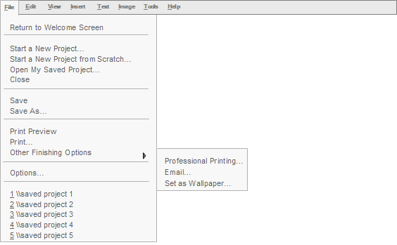
Figure is representative of File menu only.

Return to welcome screen
Opens Welcome Screen.

Start a New Project
Opens a windows-like dialog box to allow user to browse their purchased PAH design collections by name with corresponding preview image (same image that is used on main collection navigation page).

Start a New Project from Scratch
Opens the blank template wizard

Open My Saved Project
Opens a windows-like dialog box to allow user to browse their projects by name with corresponding preview image (if we can create an image of a user’s saved project, if not name only is fine.)

Close
Closes the active project in the workspace and returns the user to the Welcome Screen. User must have a project opened in the workspace for this feature to be enabled.

Save
Saves the active project that is in the workspace within it’s existing file structure. The user will see a dialog box appear asking if they want to replace the current file, with the choice of ‘yes’ or ‘no’. User must have a project opened in the workspace for this feature to be enabled. If the user has not previously saved the project, then a “Save As” dialog box will appear asking the user to assign a name to the collection (essentially creating their own collection) and then assign a secondary name to the actual project (i.e., invitation) they are saving.

Save As
Opens a dialog box that allows user to save a project that has never been saved. This dialog box will ask the user to assign a name to the collection (essentially creating their own collection) and then assign a secondary name to the actual project (i.e., invitation) they are saving. Other optional attributes the user can set are occasion and project type. The user will use the save as command each time they add a new piece to their saved collection. User must have a project opened in the workspace for this feature to be enabled.

Export / Import
Allows user to export a collection file (which contains completed projects with assets) and send via email. This functionality will allow us the flexibility in the future to enable a user to share/post projects within the community forum on the web. The import feature will allow the recipient of the email to open the collection file within the application. If the imported file was derived form a canned PAH collection, then when the recipient opens the file the corresponding assets will populate in the left rail accordingly. If the imported collection was a start from scratch or if the recipient does not own the PAH collection that the file was created with, their Creative Studio in the left rail will default into a view all mode.

Print Preview
Opens a full view of the printable template area allowing the user to see exactly how their project will print. Include options to view the subsequent pages of a project (i.e., inside/back of card), zoom in and out print and close from this screen. User must have a project opened in the workspace for this feature to be enabled.

Print
Opens the main print dialog box. If printing a non-envelope type of project, the options for user to choose from will include what we have in C&P today [printer selection (name), print preferences, number of copies to print, card size (half or ¼ fold – when applicable), option to run a print test, option to print to file, paper orientation (with graphic), paper settings (top, bottom).
If printing an envelope, the options for user to choose from will include what we have in C&P today. Other features of envelope printing should allow the user ability to designate which return address they want to use and make it the default if desires (can be plain text or a monogram) as well as set the placement for the return address (front upper left corner or back center of envelope). The user should also be able to select the option to add just the name for the inner envelope to print (which does not include an address). Envelope printing should also allow user to print envelopes in one pass (user opens flap before inserting into printer and both the mailing and return address prints in one pass through printer).
For print test (on ½ fold cards) use current process and language we have set in C&P today. UI will need to be refined.
User must have a project opened in the workspace for this feature to be enabled.

Other Finishing Options

Email
TBD on how this will work based on information needed from tech team regarding converting to a PDF file. Ideally the user would be able to convert their project to an electronic format and email.

Professional printing (phase 2)
This is remote fulfillment – TBD

Set as Wallpaper (phase 2)
Set an image as a wallpaper for use on user’s computer and/or mobile phone.

Options

One Click Shopping
This command allows the user to set up their preferences for one click shopping. Currently part of phase 2. Details to come.

Ruler Settings
Allows user to change ruler settings from inches to cm. Default will be inches.

Settings for My Images/Photos Library of Creative Studio
Allows the user to designate the file that populates into the My Images/Photos section of the left rail.

Recent Projects
List of last 5 recent projects user worked on. Click on name to open project into workspace.

Edit
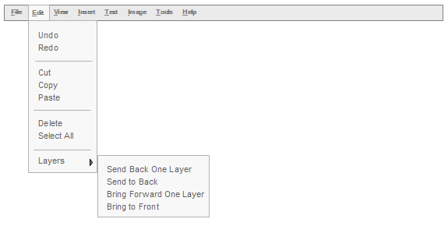
Figure is representative of Edit menu only.

Undo
Functions with same logic as in C&P today. Must be able to differentiate between projects so it’s only undoing actions related to open project in workspace, and not crossing over into other related projects.

Redo
Functions with same logic as in C&P today. Must be able to differentiate between projects so it’s only redoing actions related to open project in workspace, and not crossing over into other related projects.

Cut
Allow user to cut/copy/paste items across projects. User must have an asset selected within the workspace for this feature to be enabled.

Copy
Allow user to cut/copy/paste items across projects. User must have an asset selected within the workspace for this feature to be enabled.

Paste
Allow user to cut/copy/paste items across projects. User must have previously cut/copied an asset to the clipboard for this feature to be enabled. Follow standard logic for this feature.

Delete
Delete selected asset(s) from workspace. User must have an asset selected within the workspace for this feature to be enabled.

Select All
Allows user to select all assets that are on the printable template area of workspace.

Layers

Send Back One Layer
Functions like C&P today. User must have an asset selected within the workspace for this feature to be enabled. Size of icon TBD.

Send to Back
Functions like C&P today. User must have an asset selected within the workspace for this feature to be enabled. Size of icon TBD.

Bring Forward One Layer
Functions like C&P today. User must have an asset selected within the workspace for this feature to be enabled. Size of icon TBD.

Bring to Front
Functions like C&P today. User must have an asset selected within the workspace for this feature to be enabled. Size of icon TBD.

View
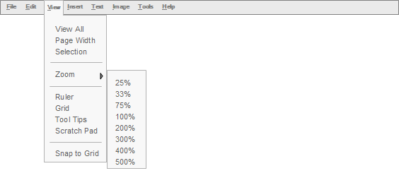
Figure is representative of View menu only .

View All
Brings entire project back into view of workspace. Same as current C&P today.

Page Width
View project at full width of workspace screen. Same as C&P today.

Selection
Enlarges selected item to full view in workspace. Same as C&P today. User must have an item selected within the workspace for this feature to be enabled.

Zoom

25%, 33%, 75%, 100%, 200%, 300%, 400%, 500%
Zooms project (or selected item) to specific percentage views. Same as C&P today.

Ruler
Displays ruler on workspace. This ruler will be display only and will be docked on top/bottom and left/right or a combination of both. Ruler will appear in inches as default. User can change to cm via options under file menu.

Grid
Displays guides on workspace. Same as C&P “Grid” functions today.

Tool Tips
Tool tips will appear throughout the user’s session. These will appear in the upper right corner of the application window. The user can control whether or not they wish to view them by selecting/deselecting this feature. The default is that this feature is always visible (in this mode there is a check mark next to “Tool Tips” in the View menu – indicating it is turned on). When deselected, the check mark is gone.

Scratch Pad – Phase 2
Opens scratch pad.

Snap to Grid
Snaps selected item(s) to grid. User must have an asset selected within the workspace for this feature to be enabled.

Insert
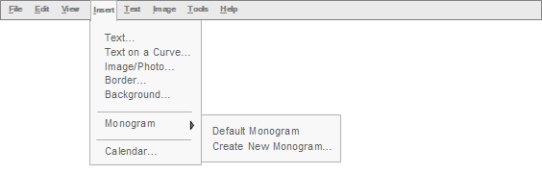
Figure is representative of Insert menu only.

Text
Inserts a new text box in the workspace.

Text on a Curve
Opens text editor.

Image/Photo
Opens a dialog box allowing user to browse both their purchased artwork as well as saved (edited) images/photos (same images that are featured in the left rail under “Artwork” and “My Images/Photos” sections). Dialog box should also include an option for user to browse their PC to insert their own photos. The dialog box should display the artwork/photos by name along with a corresponding preview image. When the desired art image/photo is selected it should appear in the workspace.

Border
Opens a dialog box to allow user to browse their purchased borders by name along with corresponding preview image (same image that is used in left rail navigation).

Background
Opens a dialog box to allow user to browse their purchased backgrounds by name along with corresponding preview image (same image that is used in left rail navigation). Option to create custom background should appear in this dialog box – when clicked opens custom background pattern wizard.

Monogram – Phase 2

Insert Default Monogram
Inserts the user’s default monogram onto the workspace (at cursor position).

Create New Monogram
Opens monogram wizard.

Calendar
Inserts a calendar object onto the workspace. Opens a dialog box to allowing user to set month, year, format and height of month and year bar, format and height of day of week bar, ability to hide unused date boxes (all or just empty rows) choice of first day of week (Sunday/Monday). All other formatting for font, text and line color and line thickness will be featured in the contextual tool bar (and appropriate section of the image editor) when the calendar is selected in the workspace. This calendar should function the same as C&P today.

Text
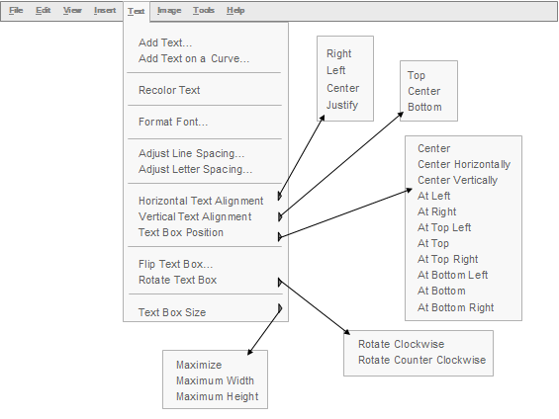
Figure is representative of Text menu only.

Add Text
Opens a new text box in the workspace.

Add Text on a Curve
Opens text editor.

Recolor Text
Opens modal color palette tool. User must have text selected within workspace for this feature to be enabled.

Format Font
Opens text editor to default formatting options. User must have a text box selected within the workspace for this feature to be enabled.

Adjust line spacing
Opens text editing tool that allows user to adjust spacing in between lines of text. User must have a text box selected within the workspace for this feature to be enabled.

Adjust letter spacing
Opens text editing tool that allows user to adjust spacing in between the letters of a word. User must have a text box selected within the workspace for this feature to be enabled.

Horizontal Text Alignment

Right
Functions same as C&P today. User must have a text box selected within the workspace for this feature to be enabled.

Left
Functions same as C&P today. User must have a text box selected within the workspace for this feature to be enabled.

Center
Functions same as C&P today. User must have a text box selected within the workspace for this feature to be enabled.

Justify
This should work the same way it does in MS Word and PowerPoint. User must have a text box selected within the workspace for this feature to be enabled.

Vertical Text Alignment

Top
Functions same as C&P today. User must have a text box selected within the workspace for this feature to be enabled.

Center
Functions same as C&P today. User must have a text box selected within the workspace for this feature to be enabled.

Bottom
Functions same as C&P today. User must have a text box selected within the workspace for this feature to be enabled.

Text Box Position

Center
Functions same as C&P today. User must have a text box selected within the workspace for this feature to be enabled.

Center Horizontally
Functions same as C&P today. User must have a text box selected within the workspace for this feature to be enabled.

Center Vertically
Functions same as C&P today. User must have a text box selected within the workspace for this feature to be enabled.

At Left
Functions same as C&P today. User must have a text box selected within the workspace for this feature to be enabled.

At Right
Functions same as C&P today. User must have a text box selected within the workspace for this feature to be enabled.

At Top Left
Functions same as C&P today. User must have a text box selected within the workspace for this feature to be enabled.

At Top
Functions same as C&P today. User must have a text box selected within the workspace for this feature to be enabled.

At Top Right
Functions same as C&P today. User must have a text box selected within the workspace for this feature to be enabled.

At Bottom Left
Functions same as C&P today. User must have a text box selected within the workspace for this feature to be enabled.

At Bottom
Functions same as C&P today. User must have a text box selected within the workspace for this feature to be enabled.

At Bottom Right
Functions same as C&P today. User must have a text box selected within the workspace for this feature to be enabled.

Flip Text Box – Phase 2
If part of the alpha this command opens text editor to flip text box functions. Flip Top to Bottom: Flips contents of text box from top to bottom (basically creating a mirror image of text). Flip Left to Right: Flips contents of text box from left to right (basically creating a mirror image of text). If part of phase 2, then user will be able to flip contents of a text box from within the workspace (also duplicated within the text editor). User must have a text box selected within the workspace for this feature to be enabled.

Rotate Text Box

Rotate Clockwise
Functions same as C&P today. User must have a text box selected within the workspace for this feature to be enabled.

Rotate Counterclockwise
Functions same as C&P today. User must have a text box selected within the workspace for this feature to be enabled.

Free Rotate
Functions same as C&P today. User must have a text box selected within the workspace for this feature to be enabled.

Text Box Size

Maximize
Functions same as C&P today. User must have a text box selected within the workspace for this feature to be enabled.

Maximum Width
Functions same as C&P today. User must have a text box selected within the workspace for this feature to be enabled.

Maximum Height
Functions same as C&P today. User must have a text box selected within the workspace for this feature to be enabled.

Image
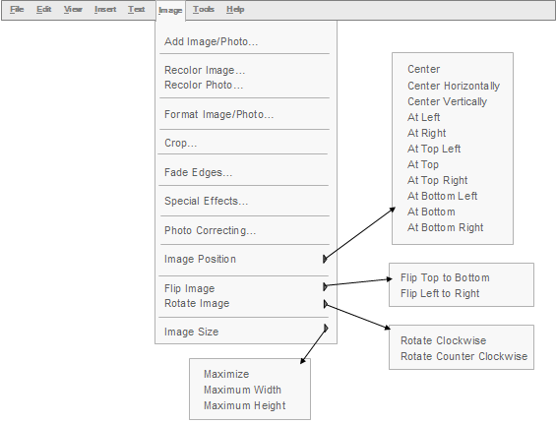
Figure is representative of Image menu only.

Add Image/Photo
Opens a windows-like dialog box to allow user to browse their purchased art assets by name with corresponding preview image (same image that is used in artwork section of left rail)

Recolor Image
Opens modal color palette tool. User must have a recolorable image selected within workspace for this feature to be enabled. If user has selected an art asset that does not support individual area recoloring, then the image editor should open to the default formatting options.

Recolor Photo
Opens image editor to photo recoloring options. User must have a photo selected within workspace for this feature to be enabled.

Format Image/Photo
Opens image editor to default formatting options. User must have an image selected within the workspace for this feature to be enabled.

Crop
Opens image editor to crop tools. User must have an image selected within the workspace for this feature to be enabled.

Fade Edges
Opens image editor to fade edge tool options. User must have an image selected within the workspace for this feature to be enabled.

Special Effects
Opens image editor to special effects tool options. User must have an image selected within the workspace for this feature to be enabled.

Photo Correcting
Opens image editor to photo correcting tool options. User must have an image selected within the workspace for this feature to be enabled.

Image Position

Center
Functions same as C&P today. User must have an image selected within the workspace for this feature to be enabled.

Center Horizontally
Functions same as C&P today. User must have an image selected within the workspace for this feature to be enabled.

Center Vertically
Functions same as C&P today. User must have an image selected within the workspace for this feature to be enabled.

At Left
Functions same as C&P today. User must have an image selected within the workspace for this feature to be enabled.

At Right
Functions same as C&P today. User must have an image selected within the workspace for this feature to be enabled.

At Top Left
Functions same as C&P today. User must have an image selected within the workspace for this feature to be enabled.

At Top
Functions same as C&P today. User must have an image selected within the workspace for this feature to be enabled.

At Top Right
Functions same as C&P today. User must have an image selected within the workspace for this feature to be enabled.

At Bottom Left
Functions same as C&P today. User must have an image selected within the workspace for this feature to be enabled.

At Bottom
Functions same as C&P today. User must have an image selected within the workspace for this feature to be enabled.

At Bottom Left
Functions same as C&P today. User must have an image selected within the workspace for this feature to be enabled.

Flip Image

Flip Top to Bottom
Functions same as C&P today. User must have an image selected within the workspace for this feature to be enabled.

Flip Left to Right
Functions same as C&P today. User must have an image selected within the workspace for this feature to be enabled.

Rotate Image

Rotate Clockwise
Functions same as C&P today. User must have an image selected within the workspace for this feature to be enabled.

Rotate Counterclockwise
Functions same as C&P today. User must have an image selected within the workspace for this feature to be enabled.

Free Rotate
TBD if this is for alpha or phase 2. This feature should be accessible from the workspace and within the image editor. User must have an image selected within the workspace for this feature to be enabled.

Image Size

Maximize
Functions same as C&P today. User must have an image selected within the workspace for this feature to be enabled.

Maximum Width
Functions same as C&P today. User must have an image selected within the workspace for this feature to be enabled.

Maximum Height
Functions same as C&P today. User must have an image selected within the workspace for this feature to be enabled.

Tools
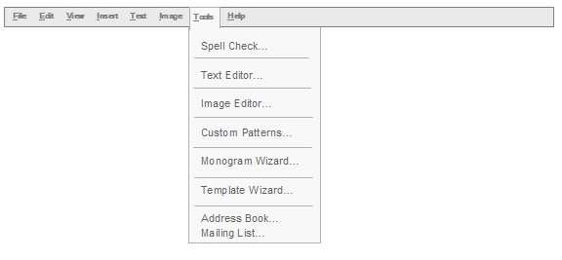
Figure is representative of Tools menu only.

Spell Check
Should function like C&P today. Checks the spelling of the entire project.

Text Editor
Opens text editor.

Image Editor
Opens image editor. User must have an image selected within the workspace for this feature to be enabled.

Custom Patterns – Phase 2
Opens custom pattern tool.

Monogram Wizard – Phase 2
Opens monogram wizard.

Template Wizard
Opens template wizard. From this position in the global (main) tool bar, this command allows the user to reconfigure the layout of the current project they’re working on. They cannot start a new project from scratch with this command (even though it is the same wizard that is used to start a new project from scratch using custom) they would need to use the open method from the file menu, left rail or welcome screen for starting new from scratch.

Address Book
Opens address book within application.

Mailing List
Takes user to mailing list section of address book where they can create a new mailing list or view/edit/duplicate existing mailing lists.

Help
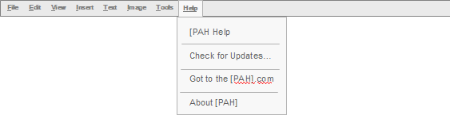
Figure is representative of Help menu only.

[PAH] Help
Opens help menu dialog box. Details TBD.

Check for Updates
Functions like C&P today. (Is this a correct assumption?)

Go to [PAH].com
Opens new browser window (size TBD) taking user to the homepage of the [PAH] website.

About
Functions like C&P today. (Is this a correct assumption?)

Contextual Tool Bars
The contextual tool bars contain the same functions found in the global (main) file menu.

Persistent File Tool Bar
The icons within the persistent file tool bar contain those functions that are available for all project types and are duplicative of the functions found in the global (main) file menu. All of these icons are active when a project is opened in the workspace. The Open and Address Book icons are the only active icons when there is no project open in the workspace.

Open
When user clicks the open icon a small drop down menu appears allowing them to choose “Start a New Project”, “Start New Project from Scratch” or “Open a Saved Project”. Size of icon TBD. When selection is made the following occurs:

Start a New PAH Project
Opens a windows-like dialog box to allow user to browse their purchased collections by name with corresponding preview image (same image that is used on main collection navigation page).

Start a New Project from Scratch
Opens the blank template wizard

Open a Saved Project
Opens a windows-like dialog box to allow user to browse their projects by name with corresponding preview image (if we can create an image of a user’s saved project, if not name only is fine.)

Save
Saves the active project that is in the workspace within it’s existing file structure. The user will see a dialog box appear asking if they want to replace the current file, with the choice of ‘yes’ or ‘no’. User must have a project opened in the workspace for this feature to be enabled. If the user has not previously saved the project, then a “Save As” dialog box will appear asking the user to assign a name to the collection (essentially creating their own collection) and then assign a secondary name to the actual project (i.e., invitation) they are saving. Size of icon TBD.

Print Preview
Opens a full view of the printable template area allowing the user to see exactly how their project will print. Include options to view the subsequent pages of a project (i.e., inside/back of card), zoom in and out print and close. User must have a project opened in the workspace for this feature to be enabled. Size of icon TBD.

Print
Opens the main print dialog box. If printing a non-envelope type of project, the options for user to choose from will include what we have in C&P today [printer selection (name), print preferences, number of copies to print, card size (half or ¼ fold – when applicable), option to run a print test, option to print to file, paper orientation (with graphic), paper settings (top, bottom).
For print test (on ½ fold cards) use current process and language we have set in C&P today. UI will need to be refined.

Envelope printing (including one-pass printing)
If printing an envelope, the options for user to choose from will include what we have in C&P today. Other features of envelope printing should allow the user ability to designate which return address they want to use and make it the default if desires (can be plain text or a monogram) as well as set the placement for the return address (front upper left corner or back center of envelope). The user should also be able to select the option to add just the name for the inner envelope to print (which does not include an address). Envelope printing should also allow user to print envelopes in one pass (user opens flap before inserting into printer and both the mailing and return address prints in one pass through printer).

Email
TBD on how this will work based on information needed from tech team regarding converting to a PDF file.

Address Book
Opens local address book within application.

Mailing List
Opens mailing list window within local address.

Persistent Workspace Tool Bar
The icons within the persistent workspace tool bar contain those functions that are available for both images and text and are duplicative of the functions found in the global (main) file menu. The zoom in/out is active when a project is opened in the workspace and/or when an item is selected. The undo/redo icons are only active once there is a history. The delete and layering icons are active when an item is selected. The select next/previous icon is always active.

Zoom In
Zooms out on project (or selected item). Same as C&P today. Size of icon TBD.

Zoom Out
Zooms out on project (or selected item). Same as C&P today. Size of icon TBD.

Undo
Functions with same logic as in C&P today. The undo function is only active once there is a history. Must be able to differentiate between projects so it’s only undoing actions related to open project in workspace, and not crossing over into other related projects. Size of icon TBD.

Redo
Functions with same logic as in C&P today. The redo function is only active once there is a history. Must be able to differentiate between projects so it’s only redoing actions related to open project in workspace, and not crossing over into other related projects. Size of icon TBD.

Layers

Select Next Layer
Functions like C&P today.

Select Previous Layer
Functions like C&P today.

Send Back One Layer
Functions like C&P today. User must have an asset selected within the workspace for this feature to be enabled. Size of icon TBD.

Send to Back
Functions like C&P today. User must have an asset selected within the workspace for this feature to be enabled. Size of icon TBD.

Bring Forward One Layer
Functions like C&P today. User must have an asset selected within the workspace for this feature to be enabled. Size of icon TBD.

Bring to Front
Functions like C&P today. User must have an asset selected within the workspace for this feature to be enabled. Size of icon TBD.

Delete
Delete selected asset(s) from workspace. User must have an asset selected within the workspace for this feature to be enabled. Size of icon TBD.

Contextual Tool Bars
The icons within the contextual tool bars contain those functions that are available based on what is selected in the workspace and are duplicative of the functions found in the global (main) file menu.

Text
To activate the contextual Text tool bar, the user must first select a text box. The rules for clicking on and within a text box are as follows:
    - A single click on text selects the text box and a blinking cursor appears within the text box
    - A double click on a word within a text box highlights that one word in the selected text box (user can also highlight a word or entire text box contents by clicking and holding down their left mouse button while selected the desired text)
    - A triple click on a word within a text box highlights the entire contents of the selected text box
    - Double clicking on the actual text box launches the text editor

Font Style
Allows user to change font style. Fonts appear in a drop down menu in their actual style (same as C&P today). Default font is that of selected text box/word/letter. User can apply a font style to an entire text box or selected words/letters within a text box. A text box/word/letter must be selected for this icon to appear in the contextual tool bar. Size of icon and drop down menu TBD.

Font Color
Allows user to change color appearance of any text box, word or letter. A text box, word or letter must first be selected before user can choose to recolor it. When chosen, the modal color palette tool opens. A text box/word/letter must be selected for this icon to appear in the contextual tool bar. Size of icon TBD.

Font Size
Allows user to change font size. Font sizes appear in a drop down menu (same as C&P today). Default font size is that of selected text box/word/letter. User can apply a font style to an entire text box or selected words/letters within a text box. A text box/word/letter must be selected for this icon to appear in the contextual tool bar. Size of icon and drop down menu TBD.

Bold
Allows user to make an entire text box/word/letter bold faced. A text box/word/letter must be selected for this icon to appear in the contextual tool bar. Size if icon TBD.

Italic
Allows user to make an entire text box/word/letter italic. A text box/word/letter must be selected for this icon to appear in the contextual tool bar. Size if icon TBD.

Underline
Allows user to underline an entire text box/word/letter. A text box/word/letter must be selected for this icon to appear in the contextual tool bar. Size if icon TBD.

Align Text to Right
Allows user to set alignment of text within a text box to the right. User must have a text box selected within the workspace for this feature to be enabled.

Align Text to Left
Allows user to set alignment of text within a text box to the left. User must have a text box selected within the workspace for this feature to be enabled.

Align Text to Center
Allows user to set alignment of text within a text box to the center. User must have a text box selected within the workspace for this feature to be enabled.

Justify
Allows user to set justify alignment of text within a text box. This should work the same way it does in MS Word and PowerPoint. User must have a text box selected within the workspace for this feature to be enabled.

Adjust line spacing
Allows user to adjust spacing in between lines of text. A text box must be selected for this icon to appear in the contextual tool bar. Size if icon TBD.

Adjust letter spacing
Allows user to adjust spacing in between the letters of a word. A text box/word/multiple letters must be selected for this icon to appear in the contextual tool bar. Size if icon TBD.

Rotate a Text Box
Works like C&P today. Size if icon TBD. Free rotate will be part of phase 2.

Free Rotate Text Box
Functions same as C&P prior to refresh of 2005. User must double click on text box to activate free rotation handle in workspace or single click on text box and then choose free rotate from the contextual tool bar.

Text Box Alignment, Size and Orientation
Opens text editor to the tools that allow a user to adjust alignment (vertical/horizontal), text box position, text box and maximize text box size. Size of icon TBD.

Artwork/Photos (Images)
To activate the contextual tool bar for artwork/photos, the user must first select (single click) on an image. When an image is selected the free rotation cues should be activated (similar to C&P today). A double click on the image opens the image editor. A roll over tip will alert the user if an image is recolorable.

Change Color
When user clicks the recoloring icon, the image editor should open revealing the recoloring options for that particular image/photo along with the image loaded into the preview window of the editor. User must have an image selected within the workspace for this feature to be enabled or they can also double click on image to launch editor and then navigate to the color fill tools. Size of icon TBD.

Change to Black & White
When user clicks the b/w icon, the image editor should open revealing the change/convert to black and white tool for that particular image/photo along with the image loaded into the preview window of the editor. User must have an image selected within the workspace for this feature to be enabled or they can also double click on image to launch editor and then navigate to the B&W tool. Size of icon TBD.

Crop Image/Photo
When user clicks the crop icon, the image editor should open revealing the cropping tools for that particular image/photo along with the image loaded into the preview window of the editor. User must have an image selected within the workspace for this feature to be enabled or they can also double click on image to launch editor and then navigate to the crop tools. Size of icon TBD.

Fade Edge / Add Border to Image/Photo
Opens image editor to fade edge/add border tool options. User must have an image selected within the workspace for this feature to be enabled. Size of icon TBD.

Photo Correcting
Opens image editor to photo correcting tool options. User must have an image selected within the workspace for this feature to be enabled. Size of icon TBD.

Special Effects
Opens image editor to special effects tool options (most likely phase 2). User must have an image selected within the workspace for this feature to be enabled. Size of icon TBD.

Rotate an Image/Photo
This feature should work directly in the workspace and within the image editor. 90 degree rotation works like C&P today. Size if icon TBD. TBD if free rotate will be part of alpha or phase 2.

Flip an Image/Photo
Works like C&P today. This feature should work directly in the workspace and within the image editor. Size if icon TBD.

Advanced Tools
The contextual advanced tool bar is active based on what is selected in the workspace. The text editor, monogram wizard, and template wizard icons are active even when there is nothing selected in workspace.

Text Editor
Opens text editor. User does not need to have text box/word selected within the workspace for this feature to be enabled. Size of icon TBD.

Image Editor
Opens image editor. User must have an image selected within the workspace for this feature to be enabled. Size of icon TBD.

Template Wizard
Opens template wizard. Size of icon TBD.

Custom Pattern Tool – Phase 2
Depending on what is selected in the workspace, opens the image or text editor or monogram wizard to the custom background pattern tool features. User must have an image (not photo), text box or monogram selected within the workspace for this feature to be enabled. Size of icon TBD.

Monogram Wizard – Phase 2
Opens monogram wizard. User does not have to have a text box/letters selected within the workspace for this feature to be enabled. Size of icon TBD.

Scratch Pad – Phase 2
Opens scratch pad. Size of icon TBD.

Color Picker Tool
The color picker tool should be modal so that it can be used across multiple platforms (i.e., text/image editor, monogram wizard, anywhere user can change color). The main color picker tool will feature exhaustive colors choices. This color picker tool must also feature 2 sets of most recently used colors: 1) the colors the artists used in creating the art images associated with the project and 2) the last “x” number of colors the user used while editing the project – AG to set the “x” number variable – suggest 5). The color picker tool will feature 2 palettes, one that matches solid colors and one that allows the user to set custom colors (most likely following the windows format). The color picker tool should also support the ability for a user to choose a color from anywhere in the workspace using an eye dropper.
The color picker tool should allow the user to save custom colors. Custom colors that the user saved should be accessible for any project. The custom colors should not be integrated into the main color picker. The user should have the option to delete a particular custom color. There should be no limit to the number of custom colors that the user can set. The saved custom color would appear with the name the user saved it as when rolled over.

Scratch Pad – Phase 2
The scratch pad is a separate window within the application where a user can drag various assets onto and “dock” them while they work on their project. This alleviates the user having to remember where a particular asset was if they can’t decide which one to place on their project template. The scratch pad will appear in the upper right area of the workspace. The user can control whether or not they wish to view the scratch pad by selecting/deselecting this feature in the advanced tool bar or View menu. They will also be able to view the scratch pad by clicking on the drop down arrow within the contextual tool bar (labeled “Scratchpad”). The scratchpad will feature the assets with a thumbnail and corresponding name (same as they are featured in the left rail). A user can delete items from the scratchpad by clicking on the “x” next to the asset name. Items from the scratchpad are removed when a user closes the entire project or exits the application. The assets should remain in the scratchpad while a user is switching back and forth between projects within an open collection.

Custom Pattern Tool – Phase 2
This application will allow the user the ability to create an unlimited array of custom background patterns to fill images, template backgrounds, borders, monograms, and text. The custom pattern tool should be modal so that it can be used across multiple platforms (i.e., text/image editor, monogram wizard, anywhere user can create a custom background pattern). Patterns should snap to grid (where applicable). The custom pattern tool does not apply to photos. The patterns color choices will be derived from the main and custom color palette in the application (outline/fill for shape’s background, center). This tool should allow the user the ability to determine the background fill color and the pattern shape’s detail (custom or a graphic that user browses their computer for) or they can choose from a predetermined list of shapes (oval, square, star, etc.). The adjustable attributes of that shape should include: width & height (lock aspect ratio), center (solid or hollow), fill color (uses main/custom color palette), fill width, line color (uses main/custom color palette), outline size, opacity level (%), inner opacity level (%), rotation (right/left), spacing between objects (across/vertical), option to stagger rows horizontally. The user should have the same attributes available when determining the alternate pattern shape. All attributes also apply for custom patterns user creates. The user should have the option to save their custom patterns in their “My Images & Photos” section of the Creative Studio. Mountaincow’s custom pattern tool is a good example to experiment with. Image below is from Mountaincow.

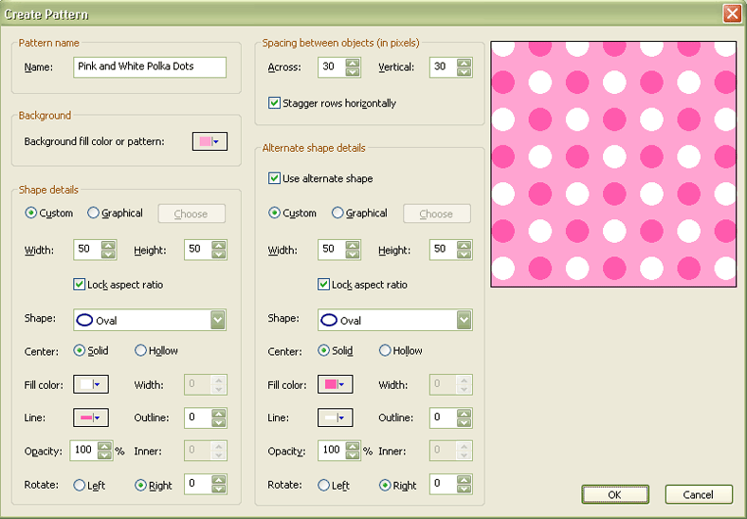

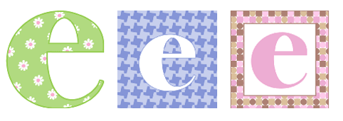

Image Editor
The image editor houses all of the advanced artwork and photo formatting features of this application such as recoloring, resizing/cropping/special effects/photo correcting. Jim M. is building out the image editor and is looking at various parts of Microsoft Picture Manager 2003 for examples, etc.
The user will launch the image editor by either double clicking on an artwork/photo asset from within the workspace or by single clicking on an artwork/photo asset and then single clicking on the image editor icon in the contextual tool bar or via the right click menu. TBD on where the image editor should appear in the workspace when the user first launches it during a project session. Once open, the user can move the editor around on the desktop, resize or maximize/minimize it. If the user moves the editor from the original spot that it opened to and then closes it, the next time they reopen it within the same session it will open to where the user last placed it.
The image editor should have a preview screen allowing the user to view their edits as they make them and give them a chance to review them before committing them to the workspace. There will be zoom in/out and undo/redo controls within the image editor. There should also be a command that allows the user to restore an image to its original state so that the user can start over on their edits for that particular image. The image editor should also have the option to “preview” edits in the workspace so that the user can view their edits in the project environment (same effect as apply). If the users chooses “preview” they will see their edits in the workspace, however the image editor will not close (they can continue to make multiple edits to their image in the image editor while the editor is opened). When sequential edits are made to an image and applied to the workspace the user should receive a prompt asking them if they want to replace the existing image with the new edits. The only way the image editor closes is if the user chooses “Done” to accept their edits, cancel to disregard their changes or by clicking the “x” in the upper right corner of the image editor. Certain functions within the editor will need to be applied before the user can move onto other edits (apply/cancel). If the user makes one of these edits (crop) and then tries to move onto another function (hue/saturation) they will be prompted to “apply” their first edits (crop) or cancel them so that the image itself can actually be changed. The apply function will only apply the user’s edits to the image within the editor and will not apply them to the workspace until the user chooses done or preview.
Example of working image editor (without any UI design):
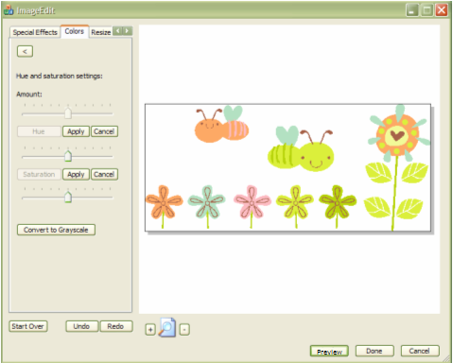

The image editor should contain a command called “Save to My Images”, which allows a user to save the edited images (default to the “My Images & Photos” section of the Creative Studio, user can also choose another location directory). When user chooses this option they will be presented with a windows-like dialog box where they can name their edited image. When a user edits an artwork image that they purchased it will not change the original artwork asset – it will always be available (and reusable) via the artwork section of the Creative Studio. Once the user saves the edited asset the windows-like dialog box closes and the editor remains opened with their edited image in the preview window until they choose one of the closing methods listed above.
This image editor needs to be extensible so that new tools/features can be added at a later date if necessary.

Recoloring
Our goal is to include an advanced recoloring tool that will allow a user to recolor an individual area of an art asset (does not include photos). Jim M. is still investigating the best method to allow the application to accomplish this. Jim M. has also stated that he believes he can include the ability to allow the user to set and control the gradation of the recolorable area (up to 2 colors) – similar to PowerPoint’s fill gradient effects. There will be certain assets that will not support recoloring an individual area; however, those assets can be recolored with an overall hue/saturation or black and white effect though.\
Based on tests between Jim M. and Jen Y. it has been determined that the best way to allow for this recoloring functionality is to have all images be bitmap with the anti aliasing turned off. The image editor will allow the user to flood fill any area within the image with a solid or gradient color (2 max) and will then need to do the anti aliasing on the fly when the image is applied to the project. The image files will need to be png’s at 300 dpi, which will allow them to be resized without losing resolution or making the file size too large.

Other options for recoloring will include adjusting hue, saturation, brightness; setting the background area of an image to transparent and changing an image to black and white. One of the choices for recoloring needs to be transparent, so that a user can add a photo into an art asset and place the photo into the "non-colored" portion of the image (ex: child's face in the center of a flower). The user can utilize the layering tool to adjust placement.

Recoloring feature list
- Color picker (modal)
  - Main swatches (RGB colors)
  - Custom colors (color wheel with slider)
  - Collection/recently used colors (colors creative used & user’s recently used colors)
  - User’s custom saved colors
- Color adjustments
  - Control hue (with control for amount)
  - Control saturation
- Brightness & contrast
  - Control brightness
  - Control contrast
- Adjust transparency/opacity
- Black & white / gray scale
- Make background transparent

Resizing / Cropping
Allows user to resize or crop an artwork asset or photo. The crop settings should be landscape/portrait and the ability to crop to a specific aspect ratio (3x4, 3x5, 4x6, 5x7, 8x10). Other options include adjusting the crop handles by pixel (left, right, top and bottom). Crop marks should appear on the asset in the preview window. The user should be able to resize the image equally by dragging from one of the four corners or resize each side separately by dragging from either the left/right/top/bottom of photo. Jim M. is looking at how Microsoft Picture Manager handles cropping as example for this application.

Resizing Feature List
- Crop
  - Aspect Ratio
    - None
    - 3x4
    - 3x5
    - 4x6
    - 5x7
    - 8x10
  - Landscape / Portrait
  - Crop Handles (control by pixel)
    - Left
    - Right
    - Top
    - Bottom
  - Show original and new picture dimensions
- Image size
  - Maximize
  - Maximum width
  - Maximum height
  - Original size
  - Predefined size
    - Document large
    - Document small
    - Web large
    - Web small
    - Email large
    - Email small
  - Custom size (pixels)
  - Percentage of original size

Photo Correcting
A user can correct various aspects of a photo (red eye reduction). More details to come on photo correcting once the functionality of this feature is flushed out with Jim M.

Photo Correcting Feature List
- Red eye reduction
- Sharpness
- Auto correct (auto brightness)

Special Effects/Faded Edge & Borders of Images & Photos
The user can add a special effect to any artwork, border, background or photo asset. The types of special effects are faded edges and overall photo effect such as blur, crystallize, etc. The user can fade the natural edges of any artwork, border, background or photo asset into a soft edge. The faded edge is a pre-determined shape such as: square, circle, heart, oval. More details to come on the overall photo effects once the functionality of this feature is flushed out with Jim M.
Special Effects Feature List
- Faded Edges (to images/photos)
  - Fade natural edge of photo
  - Fade to shape
    - Rectangle
    - Oval
    - Diamond
    - Heart
    - Star
- Add border to photo/image
  - Border and image must become one composite image in workspace (with minimal distortion to border)
  - ability to adjust hue/saturation/transparency of border
- Photo effects (refer to Photoshop for examples d – i) (some of these effects will most likely be added in phase 2)
  - Blur
  - Puzzle
  - Antiqued/aged
  - Paint daubs (PS - artistic)
  - Colored pencil (PS – artistic)
  - Ocean ripple (PS – distort)
  - Note paper (PS – sketch)
  - Water paper (PS – sketch)
  - Texture (PS)

Patterns to Fill Images& Borders/Backgrounds – Phase 2
This feature would be incorporated into the image editor and would allow a user to fill images (not photos) and borders/backgrounds with a canned pattern. This feature should also contain a link to the custom pattern tool to allow the user to create a custom pattern if they do not find what they like in our canned selection. To edit any image, border or background that has a pattern the user must use the tool that originally created the pattern.

Text Editor
The text editor houses all of the basic and advanced text formatting text functions of this application. The text editor can be accessed without any text/text box selected in the workspace. To open the text editor a user can either click the text editor icon in the contextual tool bar, single click on a text box first and then single click on the text editor icon, single click on a text box first and then right click. If a user opens the text editor from an existing text box, then the text contained within that text box should appear pre-populated into the preview window of the text editor. TBD on where the text editor should appear when the user first launches it during a project session. Once open, the user can move the editor around on the desktop, resize or maximize/minimize it. If the user moves the editor from the original spot that it opened to and then closes it, the next time they reopen it within the same session it will open to where the user last placed it.

The text editor should have a preview screen allowing the user to view their edits before committing them to the workspace. The text editor should also have the option to “apply” edits to the workspace so that the user can view their edits in the project environment. If the users chooses “apply” they will see their edits in the workspace and can continue working on their project, however the text editor will not close. The only way the text editor closes is if the user chooses “OK” to accept their edits, cancel to disregard their changes or by clicking the “x” in the upper right corner of the text editor.

The text editor will contain standard and advanced text formatting features (font style, size, alignment, position, rotate,) as well as the advanced features such as creating text on a curve. The curve options for this feature will be predetermined. If text is created using the text editor than the user must use the text editor to make any edits. If a user opens the text editor from an existing text box and edits that text with either the curving or custom pattern tool, then the new image made from the existing text box will not replace the text box (the user must delete on their own if desired). The text editor should also feature zoom in/out, opacity control, undo/redo and reset letter/line spacing. The ability to flip a text box (horizontally/vertically) and fill text with patterns will be phase 2.

This text editor should be extensible so that new tools/features can be added at a later date if necessary.

Standard text formatting functions within Text Editor
- Font style
- Font size
- Font color
- Solid/gradient options for 2 colors (same as C&P today)
- Opacity
- Bold/italic/underline
- Outline color
- Outline thickness
- Text alignment
- Text rotation

Advanced text formatting functions within Text Editor
- Text on a curve
- Adjust line spacing (increase/decrease/reset)
- Adjust letter spacing (increase/decrease/reset)
- Make text box background transparent

Patterns to Fill Text – Phase 2
This feature would be incorporated into the text editor and would allow a user to fill text with a canned pattern. This feature should also contain a link to the custom pattern tool to allow the user to create a custom pattern if they do not find what they like in our canned pattern selection. To edit any text that has a pattern the user must use the tool that originally created the pattern.

Other Text Editor Controls
- Zoom in/out/reset to original (in preview window)
- Undo/redo
- Preview (to apply edits to workspace to see in project environment)
- Done/OK
- Cancel

Monogram Wizard – Phase 2
Allows user to use any font or graphic on their computer to create a monogram. The monogram wizard tool should be modal. The attributes of this monogram tool should include inserting the initials, graphics or a combination of the two. The monogram wizard from Mountaincow is a good example for the text portion of this tool (see example below), however please note that Mountaincow does not allow for the addition of graphical images to their monograms at this time.

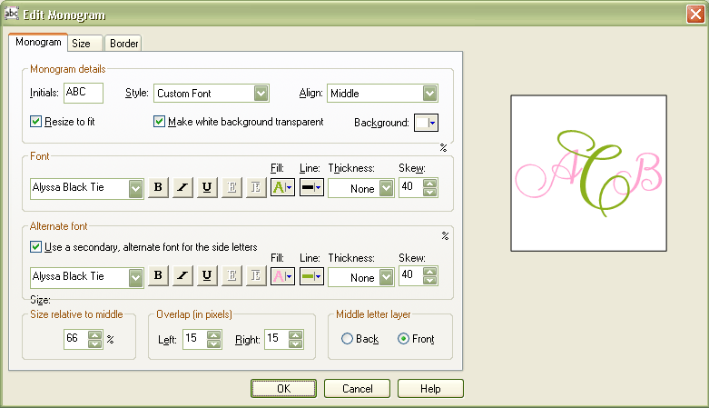

To open the monogram wizard a user can either click the monogram wizard icon in the contextual tool bar, single click on an existing monogram in the workspace first and then single click on the monogram wizard icon, single click on an existing monogram in the workspace first and then right click or by doubling clicking on an existing monogram. To create a new monogram the user must first open the monogram wizard. TBD on where the monogram wizard should appear when the user first launches it during a project session. Once open, the user can move the wizard around on the workspace, resize or maximize/minimize it. If the user moves the wizard from the original spot that it opened to and then closes it, the next time they reopen it within the same session it will open to where the user last placed it.

The monogram wizard should have a preview screen allowing the user to view their edits before committing them to the workspace. The monogram wizard should also have the option to “apply” edits to the workspace so that the user can view their edits in the project environment. If the users chooses “apply” they will see their edits in the workspace and can continue working on their project, however the monogram wizard will not close. The only way the monogram wizard closes is if the user chooses “OK” to accept their edits, cancel to disregard their changes or by clicking the “x” in the upper right corner of the monogram wizard. The monogram wizard should also offer the ability to save monograms to the "My Images & Photos" section of the Creative Studio. To edit any monogram the user must use the monogram wizard.

Font Styles
The user should be able to set the font style (from pre determined selection provided by AG creative), alignment (horizontal/vertical), background fill color (uses main/custom color palette), make background fill color transparent, adjusting specific font attributes (bold/underline/italic, embossing, fill and line color, thickness of line and skew). The monogram tool should allow for the use of an alternate font for the side letters. The attributes for the alternate font are the same as the main font. The user should also be able to adjust the size of the side letters to the middle letters, the overlap of the side letters to the middle letters, the placement of each of the letters (top, middle, bottom) to each other and the placement of the middle letter layer (front/back). Investigation with the creative team will determine if we can offer additional new fonts from what C&P has today as well as develop a couple of versions of the alphabet in the form of a stylized image. See below for examples of the various monogram styles/effects that this tool should produce:
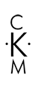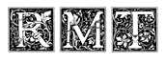

Graphics
The monogram wizard needs to support graphics. User should be able to add graphics and borders to their monograms. They should be able to adjust the color using the same recoloring attributes of the image editor (excluding the multiple area recoloring option). They should be able to designate the placement of the image relative to the monogram letters (behind, top, bottom, left, right, left top corner, right top corner, left bottom corner or right bottom corner). User should also be able to add a border to their monograms and that border should snap to grid. See below for examples of the various monogram styles/effects that this tool should produce:

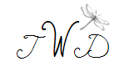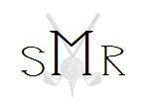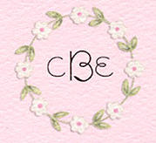



Patterns to Fill Monograms
This feature would be incorporated into the monogram wizard and would allow a user to fill monograms with a canned pattern. This feature should also contain a link to the custom pattern tool to allow the user to create a custom pattern if they do not find what they like in our canned selection. To edit any monogram that has a pattern the user must use the tool that they originally created the pattern.

Template wizard
The template wizard provides two functions: 1) wizard will allow users to adjust the size/layout, etc. of an open project. When user resizes the template of an open project a requirement is that art and text assets should automatically resize to the new dimensions as best as possible, knowing that the user may have to do some manual adjustments. 2) This wizard will also be used to allow user to set a custom size for when they are starting a project from scratch and are not using an available blank template. The range of the custom size that the user can enter should be no larger than 8x10 and no smaller than our smaller project (most likely a return address label). Attributes for the wizard include: margins, page orientation, number of ribbon holes (on applicable projects), placement of ribbon holes (top, bottom, left, right) - predetermined and custom placement (size of holes, offer option of holes being circles or small rectangles). For envelopes, the attributes include: placement of mailing and return address (margins, orientation, front/back), print on one/two sides of paper, set number of items to print per page (i.e., labels, place cards, business cards), set number folds and orientation of folds. For specific projects like place cards, the attributes should offer alternative print setting: name only, name and table number, name on outside, table number on inside. A user can launch the template wizard from the persistent contextual tool bar (icon), the main tools menu (under Tools), the right click menu and within the “Manage My Projects” section of the Creative Studio.

Phase 2 – It is the goal that for phase 2 that we will sell pre-printed paper (in the various project type forms) at a retail store. The premise behind the pre-printed templates is to offer the user a way to print high quality projects without having to deplete their ink cartridges – the bulk of the design is already pre-printed on the paper. This product will also avoid the user having to worry about setting up margins, etc. b/c the text box will be populated on the workspace in the correct position for the user, so that when they print it comes out perfectly. How it works is that the user would purchase their pre-printed project template at the retail store, visit PAH.com and download the matching projects/collections – at no cost (which are basically the electronic version of the pre-printed project template they purchased) – we will have to find a way for the user to easily locate these project templates on the website by typing in an SKU, etc.. After the user downloads their project template, they open the application, navigate to the particular collection/project and opens it. What the user sees in the workspace is the pre-arranged template. All they need to do is add their own finishing touches to it (i.e., text/photo).

Address Book
This application will need to support a local address book on the client side. A user should be able to add address information to the address book and access it for any project when creating a mailing list or printing envelopes. Ideal to allow user to import an address book (.csv file or some other standard format). The desired address book attributes are: first name, last name, name for inner envelope, mailing address, phone number, email address and relationship (friend, relative, co-worker).

Mailing Lists
The application needs to allow users to generate a mailing list from the address book for a specific project and work in conjunction with envelope printing. We should allow the user the option of creating a mailing list before or after they print envelopes. The desired user behavior is to allow the user to select which names from their address book they wish to print on the envelopes (all or individual). If user selects names to print from address book before creating a mailing list, then the user should be presented with the option of creating a mailing list from the names they just used to print the envelopes. Conversely, if the user creates a mailing list before printing envelopes, they can choose the specific mailing list vs. individual names when they do print. Additional requirements should offer the ability to duplicate a mailing list from one project for use on another project. The application should feature an option that allows the user to print a mailing list for a particular project (names only). Formatting font for envelopes should be handled via the contextual tool bar. Allowing the user to set the return address in a curve is a desired feature as well. Mountaincow’s address book/mailing list feature is a good example to look at for reference.
We will need to give this careful consideration knowing we might want to integrate this feature into AG’s online address book and reminders service at some point offering user’s a more robust solution incorporate a way for user to track projects (via online and synch with application) for RSVP’s, gifts given, responses received, thank you notes sent, etc.

Left Rail Navigation
The left rail navigation is the area of the application workspace where a user finds their primary navigation of opening/starting a new project, switching between projects within the workspace, personalizing projects with art/text assets and linking to PAH online. This left rail needs to support drag & drop functionality, sort filters/keyword search for the PAH purchased art/text assets as well as rollovers. The left rail options are revealed when the user clicks on the individual menu tabs.

Home

Return to Welcome Screen
Returns user to welcome screen.

Start a New Project
Returns user to main collection navigation screen defaulted with user’s purchased collections in view.

Start a New Project from Scratch
Returns user to the start from scratch navigation screen.

Open My Saved Project
Returns user to main collection navigation screen defaulted with user’s saved projects.

Project Manager
This section allows the user to navigate to all of the original projects related to the opened PAH collection as well as the user’s saved projects (when they’ve opened one of their own saved collections). This section’s title will feature the actual name of the collection that is opened in the workspace - when the workspace is empty this tab is not visible.

When a user first opens a PAH project they will see the related projects within that collection in this view. When they choose to switch to one of the other related projects listed in this section they will first be prompted to save any edits they have made to the current open project before they load the new project into the workspace. The action of saving a project causes a user to create their own collection (which now means they are working in their saved collection). Once this occurs this section will be refreshed into a split view featuring two sub-tabs titled “Saved” and “Related”. The “Saved” sub-tab features the list of projects contained within the user’s saved collection. The “Related” sub-tab features the entire list of PAH projects from the original related collection that their saved collection was created from.

When the user closes the workspace the application only saves the projects that user chose to save (it does not save any un-edited projects or ones that the user declined to save). At any time a user can add a new blank template to their collection by clicking the “Add blank template” button, which will launch the template wizard.
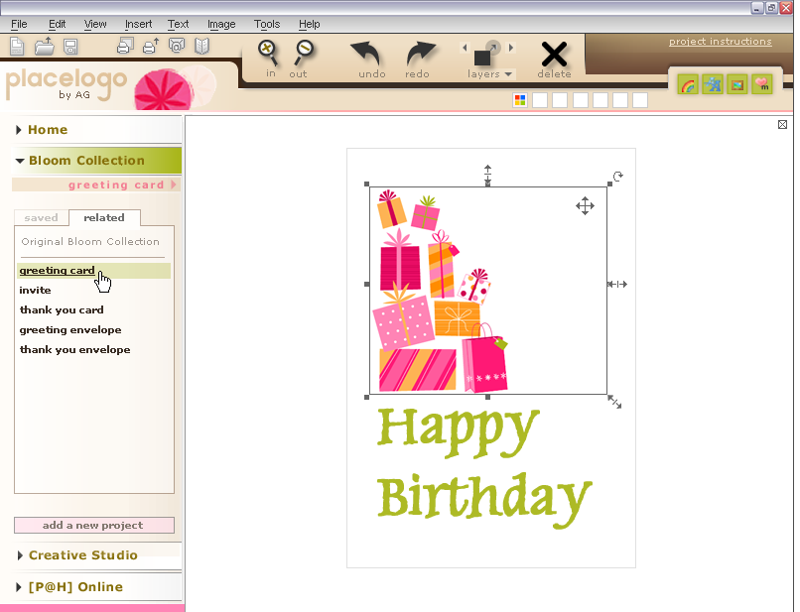
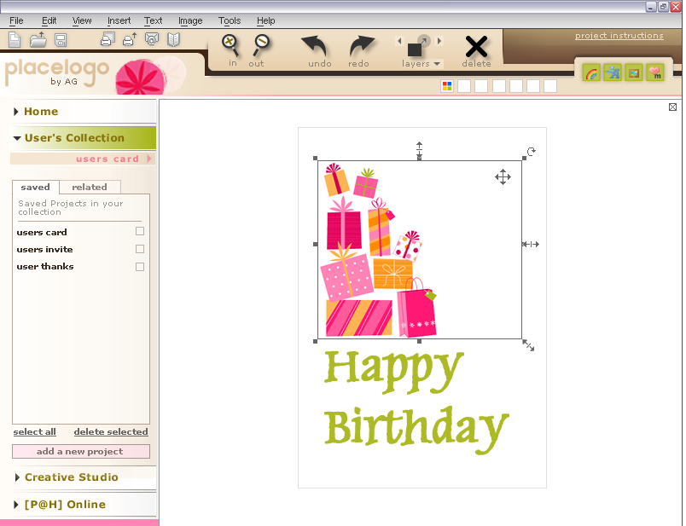

Creative Studio
The Creative Studio section of the left rail is the area where user’s can browse their art/text assets and easily add them to their projects. The thumbnails that represent the art/text assets will be a uniform size. The creative Studio contains four sections: artwork, borders/backgrounds, text/verse and my images and photos. A user can add any asset from the creative Studio to their project in the workspace by either dragging & dropping the assets onto their project or by double clicking on the asset. If the user double clicks, the asset should be dropped at a standard position (center). If the user adds multiple assets to a project consecutively then the assets should stagger so that there is no overlap.

If the user moves any art/text asset off of the printable template area, that portion of the asset that’s off of the printable template area should disappear (similar to how C&P functions today).
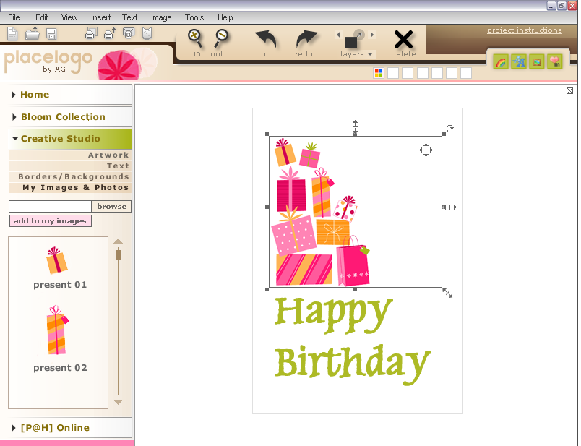

Artwork
The artwork section houses all of the coordinating artwork assets from the users purchased collections. The artwork section has a sort feature that allows user to sort by collection name, view all (alphabetical), occasion/theme and date purchased. When a user opens a collection, the corresponding artwork images appear in this section. The artwork assets are represented by a thumbnail along with the name of the asset. Rollover text will inform user how to add to their project. There is also a keyword search for artwork. The results of the keyword search are contained within the artwork section and do not cross over into any other section within the creative Studio.

Borders/Backgrounds
The borders/background section houses all of the coordinating borders and background assets from the users purchased collections. The borders/background section has a sort feature that allows the user to sort by collection name, view all (alphabetical), occasion/theme and date purchased. When a user opens a collection, the corresponding borders/background assets appear in this section. The borders/background assets are represented by a thumbnail along with the name of the asset. Rollover text will inform user how to add to their project. There is also a keyword search for this section. When a user adds a border/background to a template it should snap to grid. When a border is added to an image/photo the border should snap to the image size and then the image and border must become one composite image in workspace. The goal when adding a border to an image/photo is minimize distortion. The results of the keyword search are contained within the borders/background section and do not cross over into any other section within the creative Studio.

Text/Verse
The text/verse section houses all of the coordinating text/verse assets from the users purchased collections. The text/verse section has a sort feature that allows the user to sort by collection name, view all (alphabetical), occasion/theme and date purchased. When a user opens a collection, the corresponding text/verse assets appear in this section. The text/verse assets are represented by a few words within the beginning of the text string (exact number of characters TBD). As the user rolls over the text/verse a window expands so that they can view the entire text/verse along with information on how to add to their project. There is also a keyword search for text/verse. The results of the keyword search are contained within the text/verse section and do not cross over into any other section within the creative Studio. This section will also feature a button that allows user to add a new text box within the workspace so that they can create their own text/verse directly onto their project and a button that allows the user to add a calendar to a project. When a user chooses to add a calendar to a project a dialog box appears allowing user to set month, year, format and height of month and year bar, format and height of day of week bar, ability to hide unused date boxes (all or just empty rows) choice of first day of week (Sunday/Monday). All other formatting for font, text and line color and line thickness will be featured in the contextual tool bar (and appropriate section of the image editor) when the calendar is selected in the workspace. This calendar should function the same as C&P today.

My Images & Photos
The My Images & Photos section house the art assets that the user has edited and saved using the image editor as well as the user’s personal photos from their PC. The user’s person photos will be added to this section by way of the browse feature, which allows the user to browse their PC and add one of their own images/photos to this section. When a user clicks on the browse button a windows-like dialog box opens and displays the user’s PC file directory. The assets in this section are represented by a thumbnail along with the name of the asset. The roll over tip on any image/photos in this section will be the same as the other sections (informing user on how to add image to their project). There is no sort filter or keyword search for the My Images & Photos section.

User Flow - Starting a Project

Welcome screen
The welcome screen is visible with each launch of application and via left rail under “Home”. From welcome screen user can start a project using their purchased PAH collections, start project from scratch, open recently saved projects, open recently purchased items. Keyword search supported on welcome screen will return only collection/project results. Phase 2: other navigation links will need to support art assets only and keyword search results will display art assets (if we decide to sell art as a stand alone collection).
Other modules on the welcome screen will feature various messaging to consumer (suggested selling, community forum, etc.). When consumer clicks on messages they will be taken online via new browser window – application will not shut down. If online fresh messaging appears (as directed by AG), if offline, canned messages appear (or last message from when online appears).
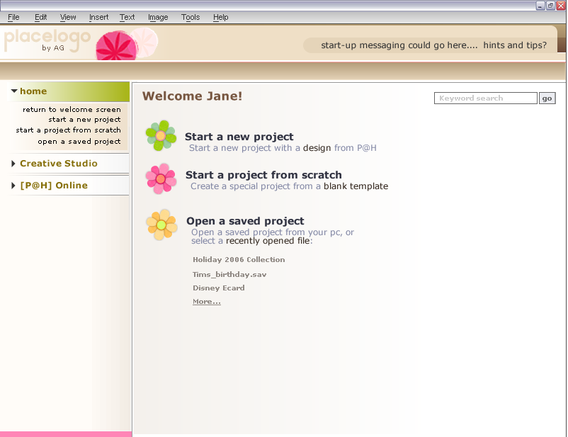

Start a New Project
The user can start a new project by using one of their purchased collections. The user will choose “Start a New Project” from the Welcome screen or from the left rail under “Home”. When they choose to start a project using one of their purchased collections via the welcome screen or left rail they will be taken to the main collection navigation screen where they can view thumbnails of all of the purchased collections. They will have the opportunity to sort their collections by occasions (birthday/wedding) or project types (greeting card/envelope), alphabetically or by date purchased (alpha/date are also sub sorts of occasions and project types). Once a user chooses a collection they will then be taken to the secondary collection screen where they will view thumbnails of the projects located within their chosen collection. From this screen they can either open a specific project or click to view details about a selected project. The details view of a project appears in a smaller window over the secondary collection screen. In this detail window the user can view the different sides of the project if applicable (front/inside/back), choose to go back to secondary collection screen or the previously view project detail page, select the project and open it into the workspace or move forward to the next project detail page of that collection or open the project. When they choose to start a project using one of their purchased collections via the main tool menu (under file) they will see the available collections listed by name in a windows-like dialog box, accompanied by a preview thumbnail.

Start a New Project from Scratch
The user can start a project from scratch by selecting “Start from Scratch” from the welcome screen, main tool menu (located under File) or from the left rail under “Home”. When they choose to start a project from scratch via the Welcome Screen or left rail they will be taken to the start from scratch navigation screen where they will view thumbs of the available blank templates contained within the application. If the desired size is not available they will click on a button/icon to “set custom size” and the template wizard will appear. When they choose to start a project from scratch via the main tool menu (under file) they will see available blank templates listed by name in a windows-like dialog box, accompanied by a preview thumbnail.

Open a Saved Project
The user can open a saved project by selecting “Open My Saved Project”, or by clicking on a project listed under the “Recent Projects” section on the welcome screen. They can also access saved projects via the main tool menu (located under File) or from the left rail under “Home”. When they choose to open a saved project from the Welcome Screen or left rail they will be taken to the saved project navigation screen where they will view thumbnails (with corresponding names) of their saved projects. When they choose to open a saved project via the main tool menu (under file) they will see their saved projects listed by name (with corresponding names) in a windows-like dialog box listed.
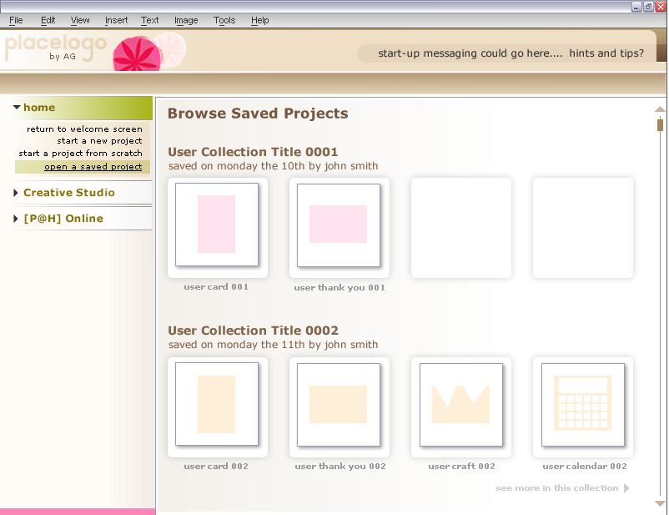

Buying Content While Working in Application
The user will be able to browse and purchase content while the application is open. If the user chooses to go online to browse/shop content, this action should spawn a new browser window (to particular shopping area on website) over workspace - does not close workspace (UI to help design this in such a way so that it appears seamless to user). The website will support one-click password sensitive shopping for those customers who wish to take advantage of it. Need feedback from tech team on how this effects the actual application (if at all).
When user buys new content while the application is open they must get a prompt at the end of the download session to refresh so that the application can recognize newly added content. User should not have to close application and reopen to do this. The newly purchased collections/projects/art & text assets should be filed according to the set standard established for this application.

Application Updates
The application needs to support auto updates.
Application should allow for new tools and components to be worked into it without causing the user to have to reinstall entire product when possible.

Right Click Menu
Details to come. Options contained within the right click menu will be context sensitive and duplicative to the features/functionality within applications other main tool bars/context menus.

Main Help Menu
Copy and details to come.

Project Instructions
Most projects will contain instructions (similar to those on C&P today). These project specific instructions should be downloaded with the collection on a printable template (8.5x11). When a project with specific instructions is opened in the workspace the user will be alerted (most likely in the upper right corner of tool bar) via a link. When the user clicks the button/icon a small window will appear displaying the instructions. The window should also feature a print button that will send the instructions to the user’s printer (appropriate messaging will be included to remind the user to take out any specialty paper they may be in their printer before printing these instructions). This small window should be able to be maximized/minimized as well as moved around the workspace. If the user moves the instruction window it will appear in the last place the user moved it to within the same session.

Roll Over Tips
This application will feature a variety of roll over tips for each and every feature and function. Copy to come.

Licensed Content
TBD on how we will handle licensed content and what measures will need to be put into place based on limitations of altering licensed content (if we choose to offer it) such as resizing, recoloring, etc.

Application Security
A requirement for this application is to set proper security measures to prevent sharing of assets among users as well as not allowing for AG assets to be used in other applications.

Content (Line List)
Alpha to include:
Collection | Collection Description | Projects | Project Description
Collection 1 | Birthday Party Gen | Greeting Card
 |  | Matching Envelope
 |  | Invitation
 |  | Matching Envelope
 |  | Thank You
 |  | Matching Envelope
 |  | Gift Tags
 |  | Gift Card Holders
 |  | Sticker/label
 |  | Boarder
 |  | Background
 |  | *Art Asset
 |  | *Art Asset
Collection 2 | Everyday Card Pack | Greeting Card | General Birthday
 |  | Envelope | Gen B-day Matching Envelope
 |  | Greeting Card | General Birthday - Age
 |  | Envelope | B-day Age Matching Envelope
 |  | Greeting Card | Just Because
 |  | Envelope | Just Because Matching Envelope
 |  | Greeting Card | Anniversary
 |  | Envelope | Anniversary Matching Envelope
 |  | Greeting Card | Wedding
 |  | Envelope | Wedding Matching Envelope
 |  | Greeting Card | Baby - General Congratulations
 |  | Envelope | Baby - Matching Envelope
 |  | Greeting Card | Thank You - Hip
 |  | Envelope | Thank You Matching Envelope
 |  | Greeting Card | Thank You - NT
 |  | Envelope | Thank You Matching Envelope
 |  | *Art Asset
 |  | *Art Asset
This free offering will also have boarders and background not associated to the above collections
* There are only 2 art assets listed, however, as the collections are created there could be more

Operating Requirements (Omniture: AG.com)
Browser Statistics Month by Month
2006 | IE6 |  | IE6 (AOL) |  | Ffox |  | MSN Exp
March | 73.0% |  | 14.1% |  | 4.6% |  | 1.8%
February | 73.1% |  | 13.5% |  | 4.7% |  | 1.8%
January | 72.7% |  | 13.8% |  | 4.7% |  | 1.7%
Source: Omniture
OS Platform Statistics
2006 | WinXP | W2000/NT5 |  |  |  | Win98 |  | MAC |  | WME
March | 83.3% | 7.2% |  |  |  | 4.3% |  | 2.6% |  | 2.2%
February | 82.2% | 7.7% |  |  |  | 4.5% |  | 2.7% |  | 2.3%
January | 82.2% | 7.7% |  |  |  | 5.2% |  | 2.7% |  | 2.5%
Source: Omniture
Display Resolution
2006 | 1024x768 |  | 800x600
March | 53.5% |  | 24.2%
February | 53.9% |  | 24.6%
January | 53.1% |  | 25.4%
Source: Omniture

Alpha Test Plan
Details to come. Plan will include a way to incorporate the ability for respondents to email their comments while working within application so that we can easily track when/where they are having difficulties.

Current C&P Bugs & Wish List

Bugs
The following items have been identified in the existing C&P will need to be investigated and fixed so that we do not adapt them into the new PAH product:

- Paper mismatch error: when user’s try to print envelopes on various HP printers they receive a paper mismatch error message because certain HP printers require an exact envelope size to be chosen and not the next largest size which is what the plug-in calls for when the exact size isn’t available.
- Sticker and label templates are outdated, and many do not display correctly due to the absence of old templates
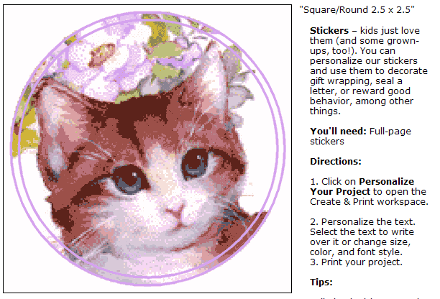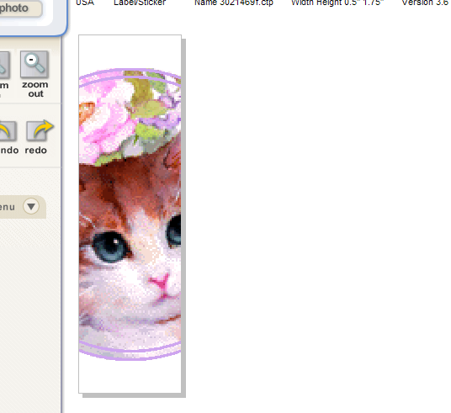
- Fix text box mode to allow user to delete entire text box using delete key, move text box using arrow keys and enable free rotate of text box in workspace – all of this without changing the current click behavior (single click to edit, double click to select all contents within text box)
        - Cannot nudge type boxes with arrow keys unless “Format>Transform>Move” is selected first
        - Free rotate is not enabled on text boxes unless “Format>Transform>Free Rotate” is selected first
        - Cannot delete text box unless you double click to select all contents first
- When printing business cards, labels and any sticker (other than full sheet), the “Number of Copies” on the print dialog box is actually the number of cards to be printed per sheet. Need to revise to read “Number printed per sheet” (should this be dynamic based on the paper type user chooses?); and add a command allowing user to enter number of copies (pages) to print
- Arrow keys do not maintain correct orientation when used after type/art is rotated (goes in opposite direction)
- Type becomes bugged once it is rotated -- cannot edit once rotated and does not size or display properly
- Project properties (in dev. tool) drop-down menu does not work – does not automatically change measurements based on the project type you choose
- When properties of an existing project change (in dev. tool), only one page changes, the other 3 remain at old size and project is unusable
- Cannot rotate lines (when added from shapes) more than 45 degrees at a time
- Many special characters (em-dash, ©, etc.) do not always work consistently (in dev. tool)
- Download new fonts without having to re-download entire application

Wish List
The following items have been identified from Creative as enhancements they would like incorporated into the new PAH as well as for the current C&P:

- Add the “select previous” and “select next” layer functionality (used to be available in the old version of C&P but user’s did understand nor utilize it, so it was removed from main workspace – it is still available in right click menu, however it would make life easier for creative if it could more easily accessible – perhaps through control keystroke?) [this is already planned as part of the tool bar in new PAH]
- Download new fonts without having to download entire plug-in [this is already planned as part of auto updates in new PAH]
- Ruler guides (moveable – new PAH will have a ruler grid on top and side, but it is not moveable)
- Ability to hold down shift and select more than one object at once (Windows standard)
- Control of leading within paragraphs of type (line spacing) [this is already planned to be part of the new PAH text editor]
- Control of tracking within lines of type (letter spacing) [this is already planned to be part of the new PAH text editor]
- Ability to free rotate images and photos in workspace [need additional time to add this functionality to new PAH product: 2 weeks to add to editors, 1 week to add to workspace]
- Ability to make thumbs .jpgs rather than .gifs as needed

